School Accountability Committee
October 2021 Meeting
4:30-5:30 PM

Present: Attendance notes will be added after the meeting.
Notes:
- SAC Members introduced themselves and shared who their children are and in what grade they attend at Harris.
- We have two new members: Welcome Adona and Laura!
- Review and approve minutes from August meeting (below)
October Meeting agenda items:
  - Review UIP – all stakeholder feedback was considered, Harris Leadership landed on three main focus areas:
    - https://har.psdschools.org/about-us/school-accountability-committee-sac

How does our UIP align with the District Ends?
    - https://www.psdschools.org/your-district/board-of-education/district-ends
What does it mean for Harris to be a Title I School?
Title I, Part A - Improving the Academic Achievement of the Disadvantaged
Title I, Part A is the largest federal program supporting both elementary and secondary education. The program's resources are allocated based upon the poverty rates of students enrolled in schools and districts and are designed to help ensure that all children meet challenging state academic standards.
Title I, Part C - Education of Migratory Children
The Migrant Education Program (MEP) supports students to reach high standards of academic achievement and is the level of interstate cooperation through the transfer of migrant students' education and health records. This high priority activity helps assure that migrant students are placed appropriately when they enroll in a new school. Their teachers are able to meet their needs and valuable time is not wasted. In addition, secondary students benefit significantly since the transfer of credits and/or partial credits assists them in meeting graduation requirements. The dropout rate among migrant students is high because of the frustration and hopelessness these students encounter when schools are not able to meet their academic needs. View Legislation
    - Where does the funding come from? Colorado Dept of Education
    - How is it used? Title 1 Teachers – Intervention team includes: Spangler, Levy, York, Tate, Rojas – they are also partially funded to support students on Read Plans – students who need literacy interventions – sometimes they are the same students.
    - Why is it used this way? It is the law
    - How is this related to the Harris Unified Improvement Plan? The areas that we need to improve our growth in includes students in these subgroups
    - How is it related to the District Unified Improvement Plan? It falls directly in line with the District Unified Improvement plan:
  - Review Title I Compact and approve
- Next Meeting times/dates:
  - February 10, 2022- 4:30-5:30 PM - Review funding and complete the district survey
  - April 14, 2022 – 4:30-5:30 PM – Agenda TBA

Minutes from August meeting below:
Principal Huerta-Kelley shared a presentation with the committee that included the ACCELERATE/BELONG slide from our superintendents’ (Brian Kingsley’s) message at the beginning of the year.
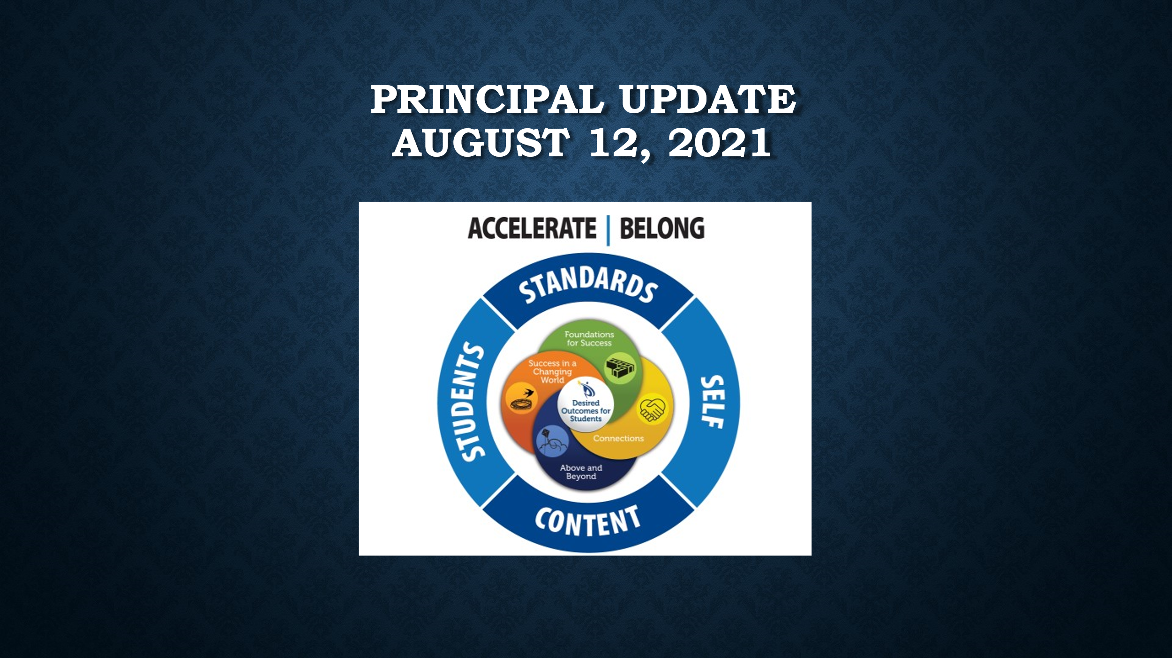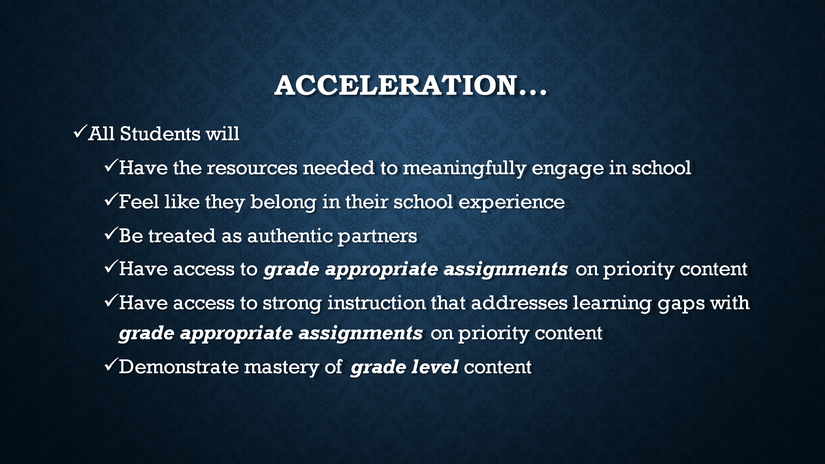

NHKelley clarified the COVID guidelines for extracurricular activities at Harris this year. The team was happy to hear that we can have clubs and activities and just have to follow our COVID guidelines.
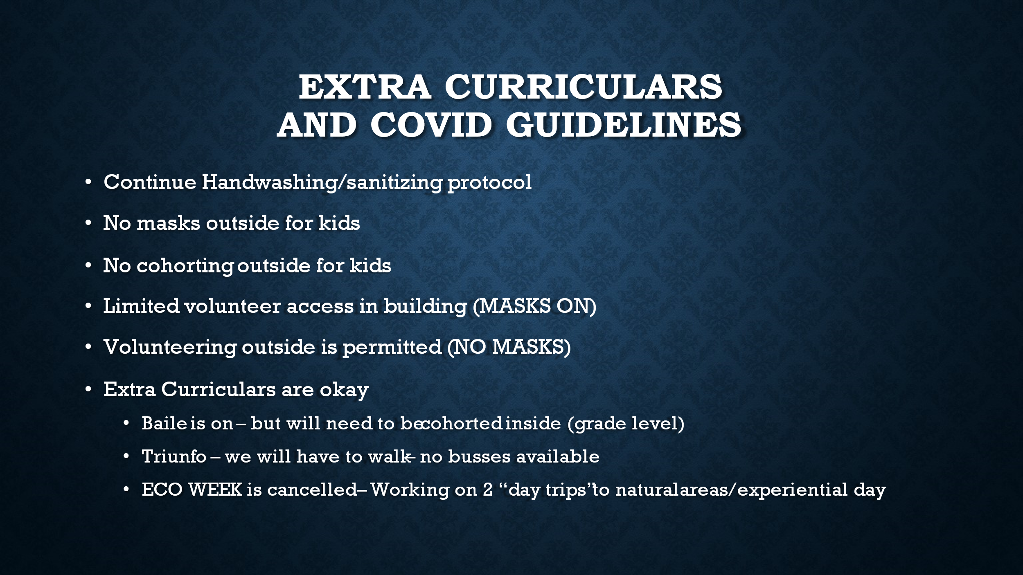
The team looked over the Unified Improvement Plan and the Major Improvement Strategies. NHKelley also went over data specific to our school (Math, Reading and AAPPL). We discussed the AAPPL assessment scores in length so that the team could understand how both language groups of students did in Spanish last year. The team was happy to see the overall scores for grades 3,4 and 5 in relationship to their peers, in schools like Harris who took this assessment in the spring of 2021.
NHKelley went over MATH and Reading data and the Connections data with the team. Based on the data, it is clear that even we did better in the spring than we originally thought we would do, we still have gaps in both math and reading that need to be improved on.
NHKelley also showed the team the 3 Pillars of Dual Language programming with a slide that shows some of the programming that is done at Harris that addresses these Pillars. NHKelley shared that at the OPEN HOUSE in September, she will share this information, the instructional programming model, ZONES of Regulation programming, Second Step programming, and the UIP Information with parents so they are clear on our model and how we teach it at Harris.
We did not have enough time to go over all the data – but NHKelley did ask the team to take the UIP home, read it and send her feedback within the week (suggestions for her to consider as they read the UIP).
The meeting ended at 5:30 PM.
Next meeting is scheduled for October 14, 2021

